Review: Centripetal Force and Centripetal Acceleration
Magnitude: $a_{c}=\frac{v^{2}}{r}, or a_{c}=rω^{2}$, $F_{c}=\frac{mv^{2}}{r}, or F=mrω^{2}$
Direction of $F_{c}$and $a_{c}$ : always points toward the center of the circle.

Circular Motion Dynamics Problems
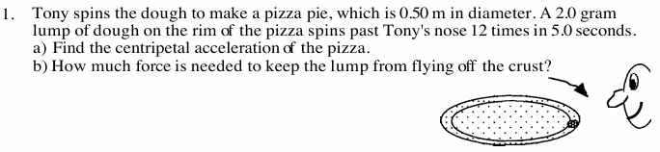

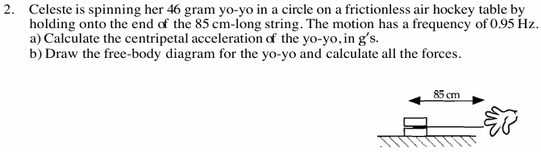

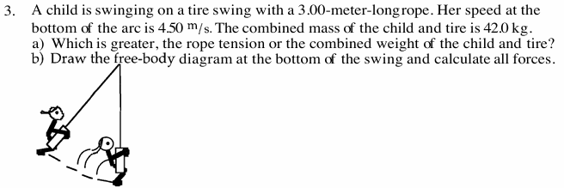

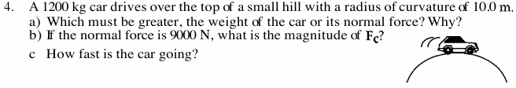

For each problem, draw the free-body diagram and show all your work.
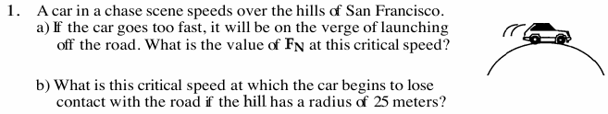

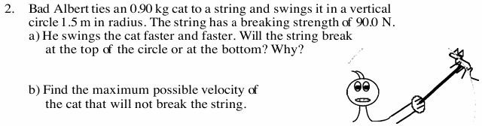

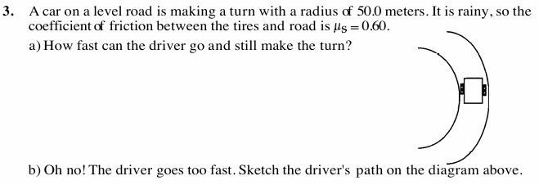
Review Problems: 10. A linear speed $v$ is called tangential speed when something moves in a circle. The rotational speed $ω$ is also called angular speed. Use $v=rω$ to answer the questions:
a) At a given distance from the axis, how does linear (or tangential) speed change as rotational (or angular) speed changes?
b) At a given rotational (or angular) speed, how does linear(or tangential) speed change as the distance from the axis changes?

15. Three locations on our rotating world are shown. Rank these locations from greatest to least
for the following quantities. a) rotational speed about Earth’s polar axis b) tangential speed

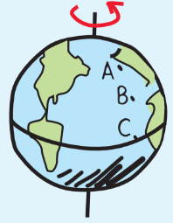Question 15 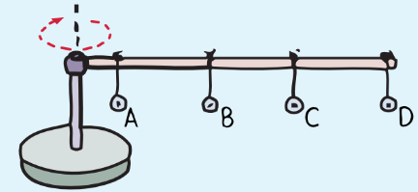Question 20

20. A meterstick is mounted horizontally above a turntable as shown. Identical metal washers are hung at the positions shown. The turntable and meterstick are then spun. Rank from greatest to least, the following quantities for the washers.
a. rotational speed, b. linear speed c. angle the string makes with the vertical d. centripetal force

21. A ball is swung in a horizontal circle as shown below. The ball swings from various lengths of rope at the speeds indicated. Rank the tension in the ropes from greatest to least.
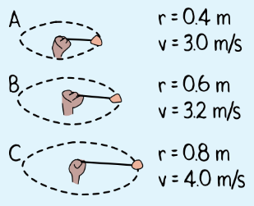Question 21 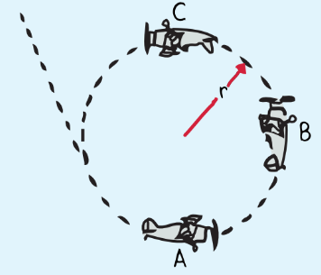Question 22

22. Paula flies a loop-the-loop maneuver at constant speed. Two forces act on Paula, the force due to gravity and the normal force of the seat pressing on her (which provides the sensation of weight). Rank from largest to smallest the normal forces on Paula at points A, B, and C.

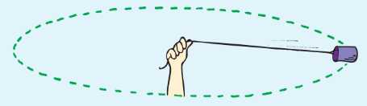

23. A string is used to whirl a 2-kg toy in a horizontal circle of radius 2.5 m. The toy moves at 3 m/s. Find the centripetal acceleration of the toy and the tension in the string(centripetal force).

25. A 2-kg iron ball is swung in a horizontal circular path at the end of a 1.6-m length of rope. Assume the rope is very nearly horizontal and the ball’s speed is 10 m/s. Calculate the tension in the rope.

31. If you lose your grip on a rapidly spinning merry-go-round and fall off, in which direction will you fly? Draw a diagram to indicate that.

33. Which state in the United States has the greatest tangential speed as Earth rotates around its axis? Explain why.

37. When a soaring eagle turns during its flight, which force(s) provides the centripetal force
To make the turn? Draw a force diagram to indicate that.

38. A car resting on a level road has two forces acting on it: its weight (down) and the normal force (up). The normal force is the support force, which is always perpendicular to the supporting surface. If the car makes a turn on a level road, the normal force is still straight up. Friction between the wheels and road is the only centripetal force providing curved motion. Suppose the road is banked so the normal force has a component that provides centripetal force as shown in the sketch. Do you think the road could be banked so that for a given speed and a given radius of curvature, a vehicle could make the turn without friction? Explain.
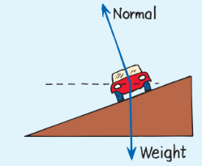
39. Friction is needed for a car rounding a curve. But if the road is banked, friction may not be required at all. What, then, supplies the needed centripetal force?

40. Under what conditions could a car remain on a banked track covered with slippery ice?

41. A racing car on a flat circular track needs friction between the tires and the track to maintain circular motion. How much more friction is required for twice the speed?

42. Can an object move along a curved path if no force acts on it?

27. Dan and Sue cycle at the same speed. The tires on Dan’s bike are larger in diameter than those on Sue’s bike. Which wheels, if either, have the greater rotational speed?

28. A large wheel is coupled to a wheel with half the diameter as shown.
a. How does the rotational speed of the smaller wheel compare with that of the larger wheel?
b. How do the tangential speeds at the rims compare (assuming the belt doesn’t slip)?


46. The sketch shows a coin at the edge of a turntable. The weight of the coin is shown by the vector W. Two other forces act on the coin: the normal force and a force of friction. The friction force prevents the coin from sliding off the edge. a) Draw in force vectors for both of these.
b) If the weight of the coin is 0.2N, the coefficient of static friction is 0.6, what is the maximum speed that the coin can rotate without skidding away from the edge of the turnable?
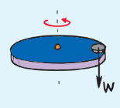

47. The sketch shows a conical pendulum. The bob swings in a circular path. The tension T and weight W are shown by vectors. a) Draw in the diagram to indicate which force provides the centripetal force to keep the bob making a circular motion. b) If the angle of tension T formed with the vertical is 30 degrees, tension in the string is 2.6 N, find the centripetal force.
